**Part A:**

total_combinations = 6 * 6

print(f"Total combinations: {total_combinations}")

# Initialize an empty 6x6 matrix

combinations_matrix = [[0] * 6 for _ in range(6)]

# Fill in the matrix with sums

for i in range(6):

for j in range(6):

combinations_matrix[i][j] = i + j + 2

# Display the matrix

for row in combinations_matrix:

print(row)

# Initialize a dictionary to store probabilities

sum_probabilities = {}

# Calculate probabilities

for i in range(2, 13):

count = sum(row.count(i) for row in combinations_matrix)

probability = count / total_combinations

sum_probabilities[i] = probability

# Display probabilities

for sum_value, prob in sum_probabilities.items():

print(f"P(Sum = {sum_value}) = {prob:.4f}")  
  
  
 **Output:**

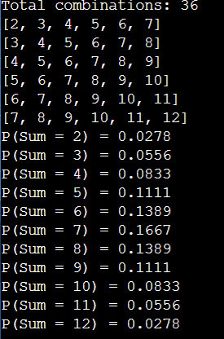

**Explanation**

* total_combinations = 6 * 6: This line calculates the total number of combinations (i.e., possible outcomes) of rolling two six-sided dice. There are 6 sides on each die, so there are 6 * 6 = 36 possible combinations.
* print(f"Total combinations: {total_combinations}"): This line prints the total number of combinations.
* combinations_matrix = [[0] * 6 for _ in range(6)]: This line initializes an empty 6x6 matrix using a list comprehension. It creates a list of 6 zeros for each row, and there are 6 rows in total.
* for i in range(6):: This line starts a loop that iterates over the range of numbers from 0 to 5 (inclusive). The variable i represents the current number in the range.
* for j in range(6):: This line starts a nested loop that also iterates over the range of numbers from 0 to 5 (inclusive). The variable j represents the current number in the range.
* combinations_matrix[i][j] = i + j + 2: This line calculates the sum of the current numbers i and j (which represent the numbers rolled on the two dice), adds 2 to account for the fact that the dice have 6 sides (i.e., the lowest possible sum is 2), and stores the result in the corresponding cell of the combinations_matrix.
* for row in combinations_matrix:: This line starts a loop that iterates over each row in the combinations_matrix.
* print(row): This line prints the current row of the matrix.
* sum_probabilities = {}: This line initializes an empty dictionary to store the probabilities of each possible sum.
* for i in range(2, 13):: This line starts a loop that iterates over the range of numbers from 2 to 12 (inclusive). The variable i represents the current sum.
* count = sum(row.count(i) for row in combinations_matrix): This line calculates the number of times the current sum i appears in the combinations_matrix. It does this by using a generator expression to iterate over each row in the matrix, counting the number of times i appears in that row, and summing up all the counts.
* probability = count / total_combinations: This line calculates the probability of the current sum i by dividing the count of that sum by the total number of combinations.
* sum_probabilities[i] = probability: This line stores the probability of the current sum i in the sum_probabilities dictionary.
* for sum_value, prob in sum_probabilities.items():: This line starts a loop that iterates over each sum and its corresponding probability in the sum_probabilities dictionary. The variables sum_value and prob represent the current sum and its probability, respectively.
* print(f"P(Sum = {sum_value}) = {prob:.4f}"): This line prints the probability of the current sum sum_value. The :.4f part of the string format specifies that the probability should be formatted as a floating-point number with 4 decimal places.